Getting Started With a PEO

How It Works and What to Expect

Working with a Professional Employer Organization (PEO) is a great way to offload your HR to experts while giving you more time to focus on your business. On top of that, you gain cost predictability and better access to health plans and benefits.

Because PEOs offer so many services and are essentially acting as your HR department, they’ll
request some documents before they can provide a price quote. This typically consists of
information about your current employees, payroll, and benefits plan. The PEO uses this for
underwriting purposes and to provide you with the most accurate price for their services.
It may seem overwhelming at first, but the information should all be readily available to you from
either your existing provider(s) or data you have handy. There are 3 main sets of data you’ll be
asked for, and potentially others depending on which services you are interested in.

How It Works
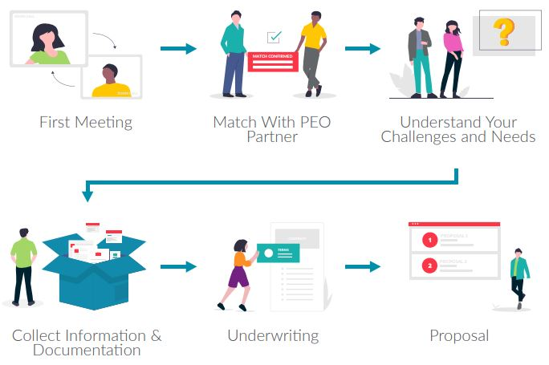
Documents You’ll Need
1. Employee Census
Employee census data consists of a list of your employees and basic information about them.
This is generally limited to name, gender, date of birth, zip code, and number of dependents.
Depending on the size of your company, it’s possible you’ll only need to provide age and
gender of employees.
The information is used for underwriting of benefits offerings and to estimate the health care
costs your group is likely to incur. It’s essential for getting accurate insurance costs. Your current payroll provider will generally have employee census data readily available for you to download.
2. Payroll Information
The next set of data you’ll be asked for is something like a payroll register. This report
provides a record of all pay details for employees during a specific pay period. The main piece
of information the PEO will be interested in is employee wages.
The payroll register provides year-to-date data that helps the PEO understand the types
of employees, existing enrollments in benefits, and any trends. It may also be used for
underwriting purposes.
Like the employee census, payroll reports should be available through your current payroll
solution.
3. Benefits Plan Information
If you’re currently offering benefits, you’ll be asked for details on your current plan.
Requested info will most likely consist of a copy of your current health benefit invoice and
details related to the plan design and employer contribution.
PEOs will use this to ensure they’re offering comparable (or in most cases better) plans and
rates. If you don’t have this information on hand, reach out to your current benefits broker or
provider and they will be able to send it over.
4. Workers’ Compensation Plan Information
Similar to health benefits, if you’re interested in workers’ comp coverage you’ll be asked for
info related to your current plan and history. Some information may already be provided with
the payroll report you provide (gross wages by employee + workers’ comp class codes). You’ll
also need to provide your workers’ compensation declaration page with a 3 year loss history.
Later in the process you may also be asked for a more detailed risk evaluation form.
PEOs need this for underwriting purposes and to ensure they can offer you the best rate and
coverage possible. This information should all be available via your current workers’ comp broker or provider.
5. Other Information
Every PEO is different, but all will ask for the set of information above. However, some may
ask for additional materials based on the services they provide. One example is Group Health
Questionnaires and Personal Health Questionnaires (requested by the insurance carrier).
These forms ask for more specific details about the medical history of your employees as a
group and individually. They help to optimize plans and get you the best rate possible from
insurance carriers.

