CONTACT
www.your-url.com
Main: 508.747.7261
Toll Free: 877.837.4311
Office Address
123 Your street
Your town, ST Zip

The new [your company name] HR Cloud is here! This next generation of HR technology gives you:
- A streamlined employee portal optimized for mobile.
- Powerful new reports, enabling you to run payroll and access the information you need in seconds.
- Robust, flexible security capabilities through role-based permissions.



Better User Experience for Employees
Employees benefit from an employee portal designed to work across smartphones, tablets, laptops, and desktops. The portal is easily customizable to represent your brand, including colors, custom background and login screen. Employees have greater flexibility to access and update their own personal information.
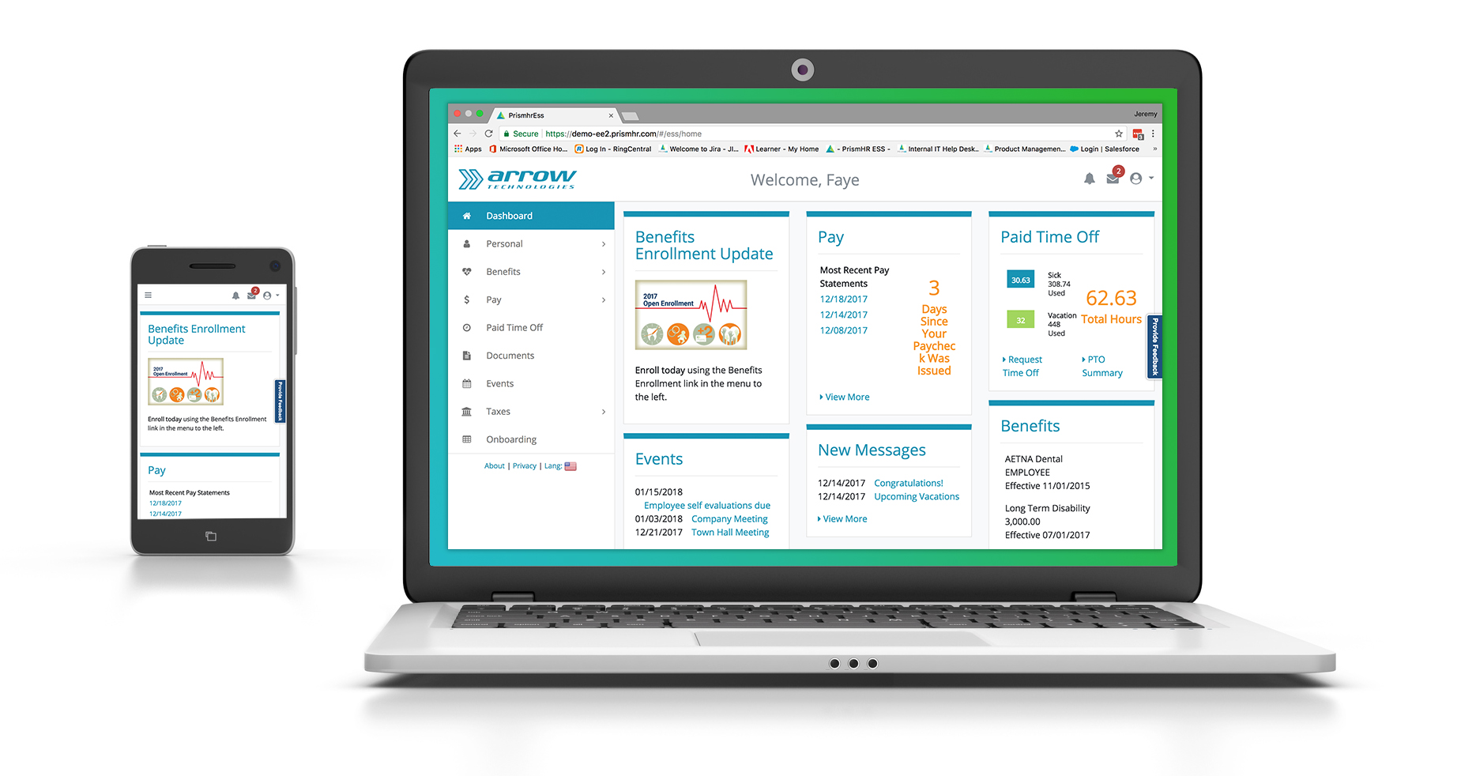

Role-based Permissions and Improved Manager Experience
HR Cloud provides powerful new security capabilities, controlling access to specific fields, menus and data, that way individuals only see what they need, when they need to. You can use roles to control access for groups or even specific individuals to ensure your team has the right access and insight they need. With role-based permissions you can offer your customers the flexibility to manage as much or as little of their workflow as they want.
With role-based permissions, training is simplified for managers who only have to learn one system. When you sign in you will immediately see that the user experience has been streamlined and consolidated for maximum efficiency. With the new favorites feature, you can create quick links to your most-used tasks.
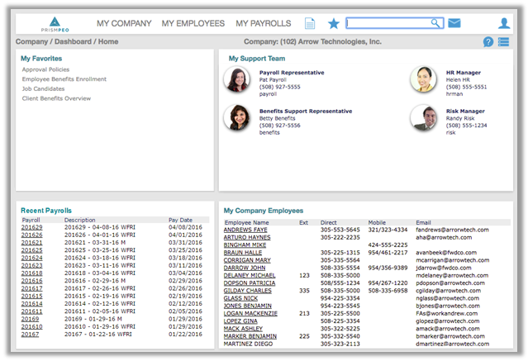

Quickly Find What You Need, With Improved Search
New search capabilities make it extremely easy for managers to find almost anything, by typing in just a few characters into the search box.
While you can search for anything, you can also apply filters to narrow your results before searching. You can filter your results to show employees, reports, or fields. To use filters, you simply enter the corresponding filter letter, followed by the search term. Common filters are below:
a: application window or menu item
e: employee name, id, etc.
f: field name
r: report name

Reporting
The new HR Cloud provides numerous pre-built reports with a wide range of customizable parameters, making it easier than ever to find the information you need. Reports are generated in real-time and immediately available.
With Data Retriever, Managers can quickly access and report on employee data whenever they want. Additionally, Managers can save templated employee reports, making it easy to quickly access the same data the next time it’s needed.
