As part of the [insert company name] HR Cloud, employee Self Service enables your employees to log in from anywhere, at any time, to view HR information and earnings statements, or view and submit time off requests.
Self Service

CONTACT
www.your-url.com
Main: 508.747.7261
Toll Free: 877.837.4311
Office Address
123 Your street
Town, ST Zip

Access from Any Device, Anywhere, Anytime

The employee Self Service portal is optimized to work across smartphones, tablets, laptops and desktops. It makes it easy for your employees to access the information they need, when they need it.

Branded and Customized Portal

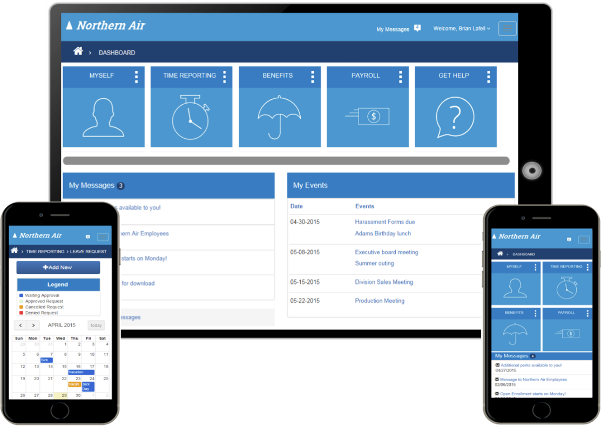
The Self Service portal is easily customizable to represent your brand, including colors, and even a custom background.

